- GIVEN THE FOLLOWING SCHEMA
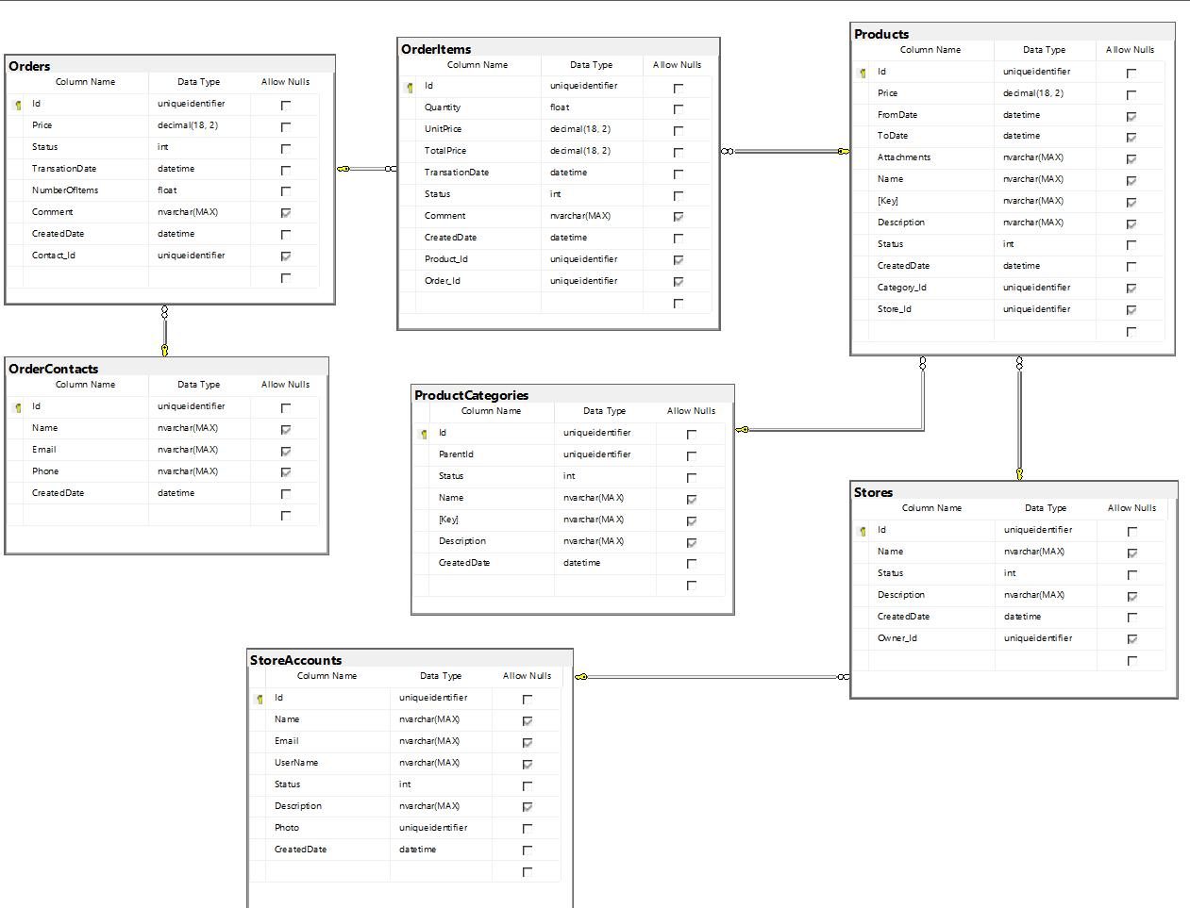

5.1 GET THE DATA

Write the SQL to answer these questions.

What is the total price of all orders?

Select SUM(Price) as TotalPrice from Orders

On average, how many products are sold per order?

Select AVG(NumberOfItems) as Average from Orders

Which order was the largest in terms of the unit price?

Select ProductID, ProductName, SupplierID, CategoryID, Unit, MAX(Price) as Price from Orders

5.2 OPTIMISE

Suggest ways this schema could be optimised.

There is a fair amount of duplication in the tables that can be removed. Order table doesn’t need columns Price, Status or NumberOfItems since these are duplicated from the OrderItems or Products table. Product Categories has an unknown ParentId column that doesn’t appear to reference any table. Stores has an unknown OwnerId column that should be renamed to StoreAccountsId. Store Accounts has a photo column of type uniqueIdentifier that should be of Binary type instead.
OrderItems doesn’t need UnitPrice since it’s set in Products table. It doesn’t need TotalPrice since it is a calculated value.

